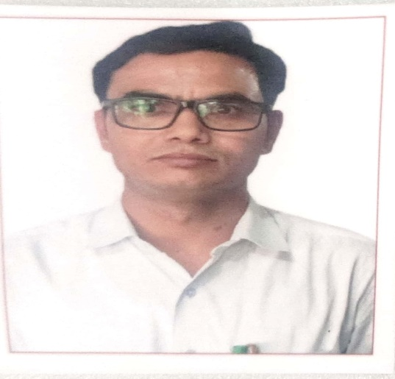  Dr. Deepak Parashar  Designation: Principal  Subject: Sanskrit  Qualification:Ph.D Education  Master Degree :Ph.D.  Download |   Dr. Gopal Krishna Bhardwaj  Designation: Asstt. Professor  Subject: Economics  Qualification:Ph.D Education  Master Degree :Ph.D.  Download
  Dr. Shankar Lal Kajala  Designation: Asstt. Professor  Subject: Botany  Qualification:Ph.D. Botany  Master Degree :Ph.D.  Download |   Mr. Kuldeep Singh  Designation: Asstt. Professor  Subject: History  Qualification:NET  Master Degree :NET  Download
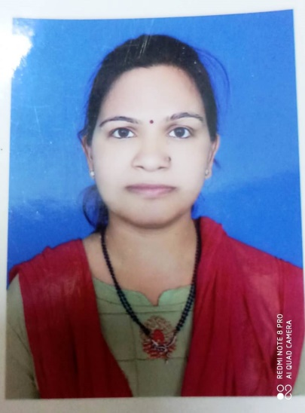  Mrs. Ruchi Maheshwari  Designation: Asstt. Professor  Subject: Botany  Qualification:M.Sc. M.Ed.  Master Degree : M.Sc. M.Ed.  Download |   Mr. Mahendra Singh Bohra  Designation: Asstt. Professor  Subject: Geography  Qualification:NET  Master Degree :NET  Download
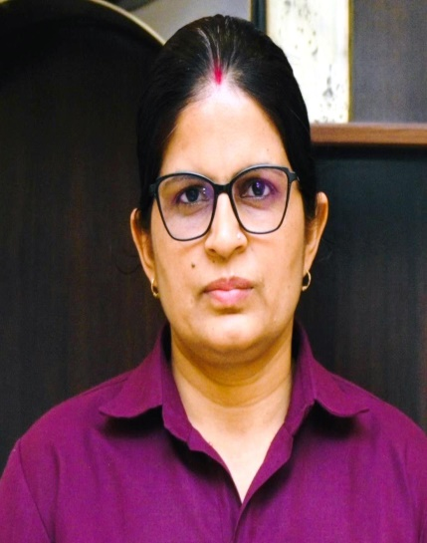  Dr. Amrita Chaudhary  Designation: Asstt. Professor  Subject: English  Qualification: Ph.D Education  Master Degree : Ph.D.  Download | 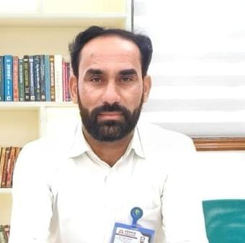  Mr. Pradeep kumar Sharma  Designation: Asstt. Professor  Subject: Political Science  Qualification:NET  Master Degree :NET  Download
  Dr. Deendayal Sharma  Designation: Asstt. Professor  Subject: Chemistry  Qualification:Ph.D. Chemistry  Master Degree :Ph.D.  Download | 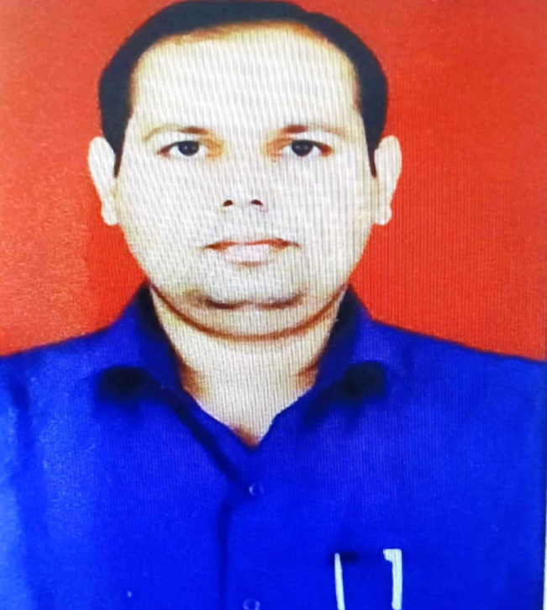  Dr. Manish Kumar Yadav  Designation: Asstt. Professor  Subject: Zoology  Qualification:Ph.D. Zoology  Master Degree :Ph.D.  Download
  Dr. Ratnesh Kumar Tripathi  Designation: Asstt. Professor  Subject: Hindi  Qualification:Ph.D. Education  Master Degree :Ph.D.  Download |   Mrs. Kalpana Sharma  Designation: Asstt. Professor  Subject: Zoology  Qualification: NET  Master Degree : NET  Download
Mrs. Mala Soni  Designation: Asstt. Professor  Subject: Draw. & Ptg.  Qualification: M.A.  Master Degree : M.A.  Download | Dr. Krishana Maurya  Designation: Asstt. Professor  Subject: Draw. & Ptg.  Qualification: Ph.D. Drawing & Painting  Master Degree : Ph.D.  Download
  Mr. Vijay Khedar  Designation: Asstt. Professor  Subject: Physics  Qualification:NET  Master Degree :NET  Download |   Dr. Irfan Khan  Designation: HOD  Subject: Chemistry  Qualification:Ph.D Chemistry  Master Degree :Ph.D.  Download
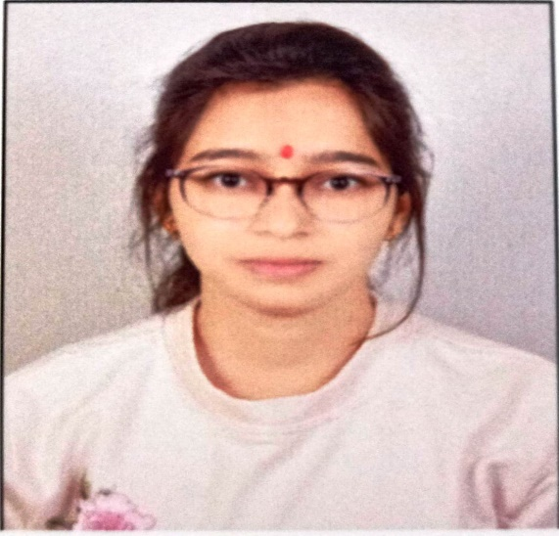  Mrs. Sakshi Sharma  Designation: Asstt. Professor  Subject: Physics  Qualification:M.Sc. B.Ed.  Master Degree : M.Sc. B.Ed.  Download | 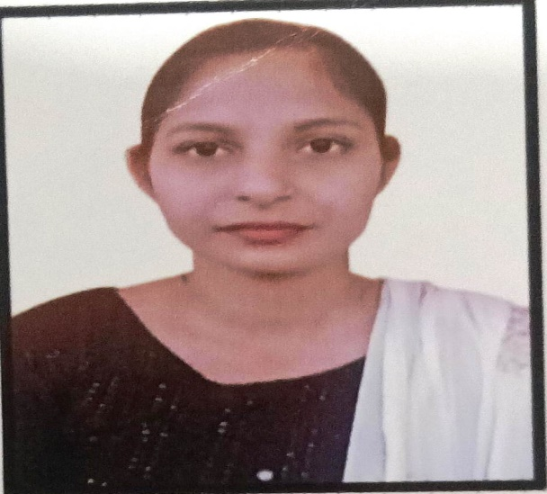  Mrs. Divya Deedwania  Designation: Asstt. Professor  Subject: Mathematics  Qualification:M.Sc. NET  Master Degree : M.Sc. NET  Download


Mrs. Sarita
Designation: Asstt. Professor
Subject: Physical Education
Qualification: B.P.Ed.
Master Degree : B.P.Ed.
Download

